We have the pleasure in inviting you to participate in our

**9th Annual Owners Conference 3rd October 2024**

The Meeting Place

Level access is available via Royal Terrace Lane. Please call in advance.

Glasgow West

5 Royal Crescent

Glasgow

G3 7SL

­­­

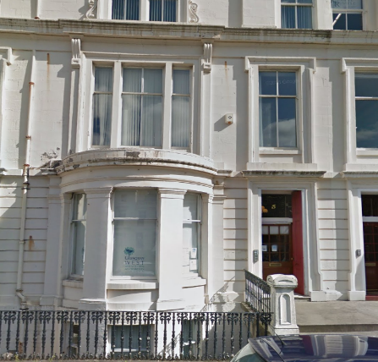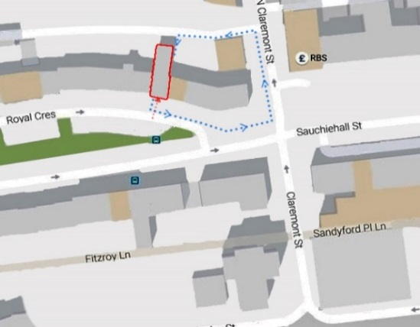

Central Gurdwara Singh Sabha

To help us plan for our 9th Owners Conference, please let us know if you will be attending this Event in person or virtually.

RSVP factoring on 0141-331 6673 or email

[factoring@glasgowwestha.co.uk](mailto:factoring@glasgowwestha.co.uk)

If you would like to attend the event virtually, please confirm your name and property address along with the email address you will be using to the factoring team no later than **26 September 2024.**

In order to help with the smooth running of this event please also submit any questions to us in advance of the conference on or before

**23 September 2024**. Where any issue raised is specific to you or your home it may be that we respond to you individually.

Thank You for Your Support!

Your Views Shape Our Services

**AGENDA**

A G E N D A

**5.00pm Surgeries**\* **/ Registration / Coffee**

**5.45pm** **Welcome**

**5.50pm Factoring Services**

**5.55pm Service Achievements over 2023/24**

**6.05pm Common Area Investment / Planned Service Procurement**

**6.15pm Questions/ Evaluation Forms/Future Engagement**

**7.00pm** **Conclusion & Thanks**

**\*STAFF SURGERY\***

Please take the opportunity to highlight matters that are specific to you, at the staff surgery. These matters will be attended to on our return to the office.

Our Conference is intended to share achievements and plans and not to discuss specific customer issues / ongoing matters.